|  |
| --- |
| **Second Year Computing**  **Web Programming and Databases**  **Solutions to Lab Sheet 3**  **Completion Date: Friday 19/11/2021**  Please save your files for this exercise sheet on your M :\WebDev*Your name* folder in a subfolder called Lab3.  **Task 1**  Type in the following code to present the user with a form to fill in student details:  **Code already given in task.**  **Task 2**  Using an external style sheet and any other html mark-up that you need, style the form from *task1* to make it more professional looking, easier to use, prettier!!  Just giving the html code here: |
|  |

**Task 3**

Modify the previous file (*task 2*) to add in fields and labels to allow the user to enter:

An email address, that is required; A website address in the correct format; A date of birth:

**Just the html here:**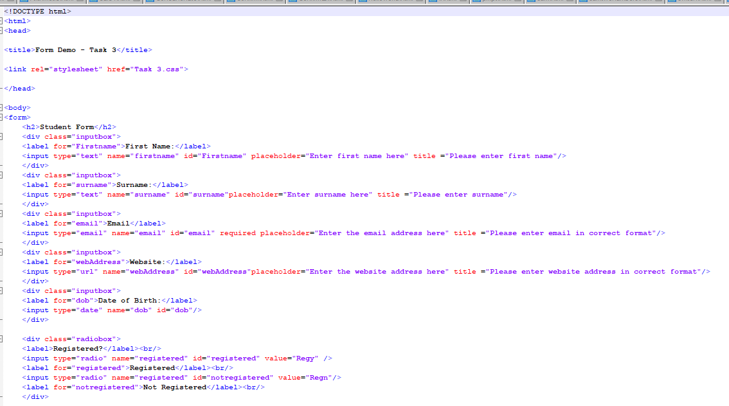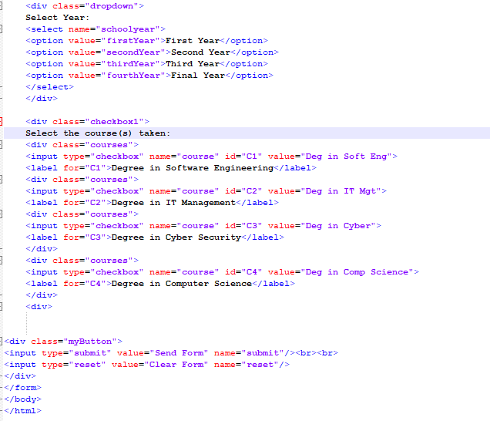

**Task 4**

Create a form that the user can use to enter details from a customer.

Include the customer’s

* Name
* Address
* phone number
* email address
* website address
* date of birth
* current customer (radio buttons, yes or no)

**HTML only:**

* number of children in household (0 to 10!)
* satisfaction rating with company (0 to 10) with slider
* checkbox for whether or not customer has certain electrical appliances (4)

**:**